11)You can still create the static website and Dockerize it without using **VS Code**. Here's how you can do everything using just the command line and a text editor of your choice (e.g., Notepad on Windows, Nano on Linux/macOS, or any editor you prefer).

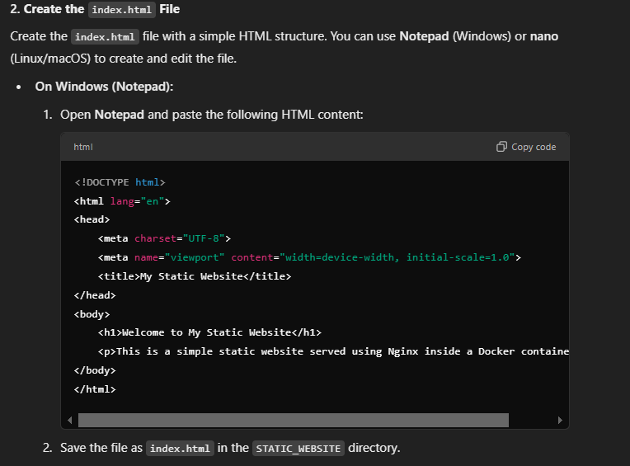

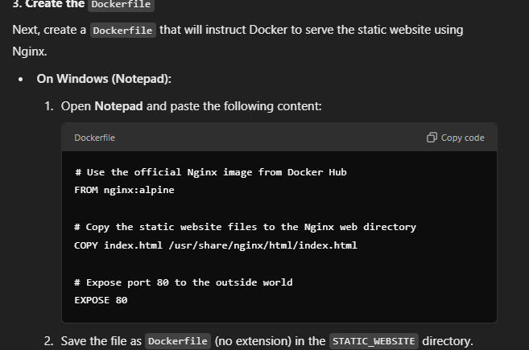

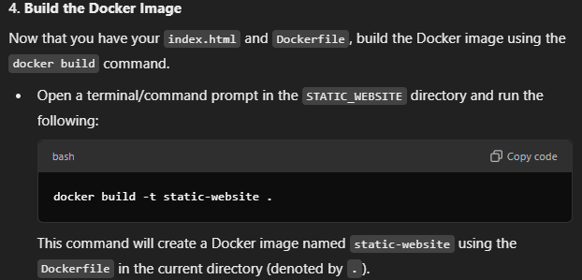

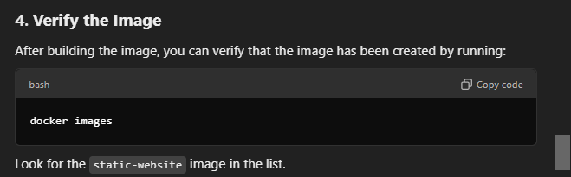

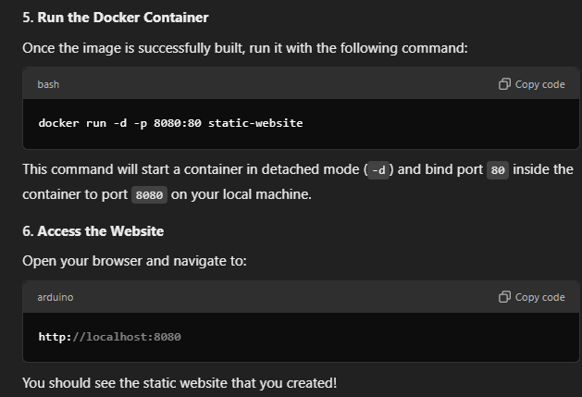

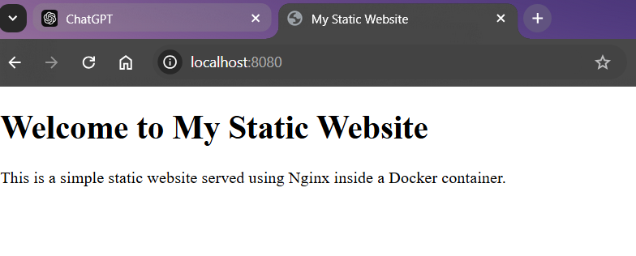

12) 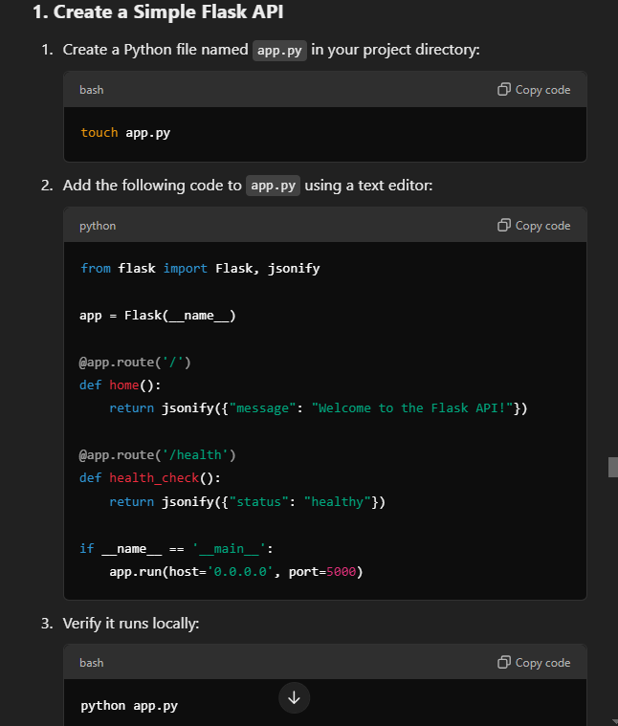

Python-

from flask import Flask, jsonify

app = Flask(__name__)

@app.route('/')

def home():

return jsonify({"message": "Welcome to the Flask API!"})

@app.route('/health')

def health_check():

return jsonify({"status": "healthy"})

if __name__ == '__main__':

app.run(host='0.0.0.0', port=5000)

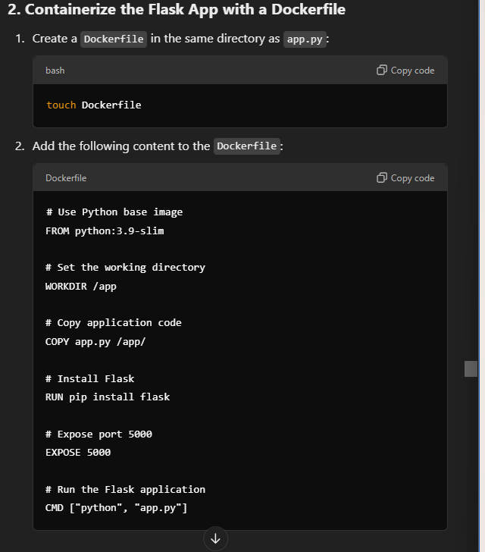

# Use Python base image

FROM python:3.9-slim

# Set the working directory

WORKDIR /app

# Copy application code

COPY app.py /app/

# Install Flask

RUN pip install flask

# Expose port 5000

EXPOSE 5000

# Run the Flask application

CMD ["python", "app.py"]

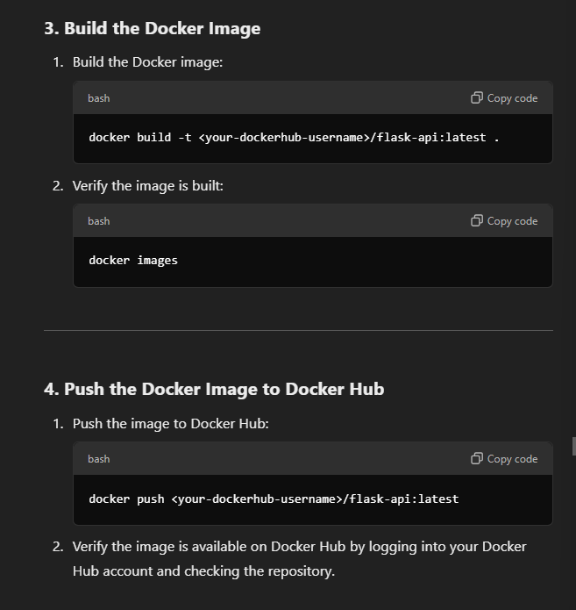

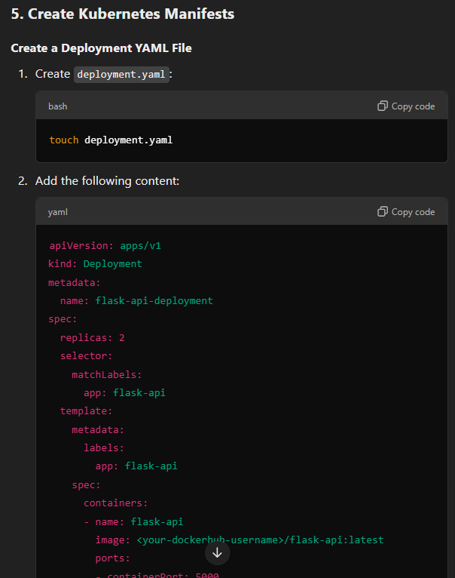

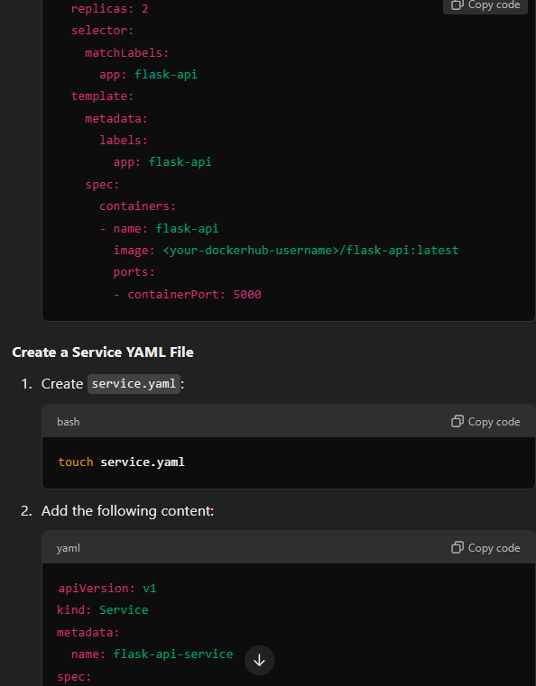

apiVersion: apps/v1

kind: Deployment

metadata:

name: flask-api-deployment

spec:

replicas: 2

selector:

matchLabels:

app: flask-api

template:

metadata:

labels:

app: flask-api

spec:

containers:

- name: flask-api

image: <your-dockerhub-username>/flask-api:latest

ports:

- containerPort: 5000

2 yaml

apiVersion: v1

kind: Service

metadata:

name: flask-api-service

spec:

selector:

app: flask-api

ports:

- protocol: TCP

port: 80

targetPort: 5000

type: NodePort

